ERS DAY 3
1.length without function
#include <stdio.h>

int main() {
char str[200];
int i = 0, length = 0;

printf("Enter a string: ");
scanf("%[^\n]", str);

while (str[i] != '\0') {
length++;
i++;
}

printf("Length = %d\n", length);

return 0;
}
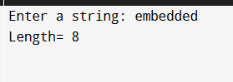
2.remove all character occurance
#include <stdio.h>

int main() {
char str[200], ch;
int i = 0, j = 0;

printf("Enter: ");
scanf("%[^\n]", str);

printf("Enter char: ");
scanf(" %c", &ch);

while (str[i] != '\0') {
if (str[i] != ch) {
str[j] = str[i];
j++;
}
i++;
}
str[j] = '\0';

printf("String: %s\n", str);

return 0;
}
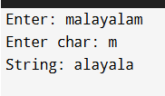
3.string palindrome
#include <stdio.h>
#include <ctype.h>

int main() {
char str[200];
int i = 0, j, len = 0;

printf("Enter: ");
scanf("%[^\n]", str);

while (str[len] != '\0') {
len++;
}

i = 0;
j = len - 1;

while (i < j) {
while (!isalnum(str[i]) && i < j)
i++;

while (!isalnum(str[j]) && i < j)
j--;

if (tolower(str[i]) != tolower(str[j])) {
printf("Not Palindrome\n");
}

i++;
j--;
}

printf("Palindrome\n");
return 0;
}
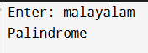
4.lower to upper case
#include <stdio.h>
int main() {
char str[200];
int i = 0;

printf("Enter: ");
scanf("%[^\n]", str);

while (str[i] != '\0') {
if (str[i] >= 'a' && str[i] <= 'z') {
str[i] = str[i] - ('a' - 'A');
}
i++;
}

printf("result: %s\n", str);

return 0;
}
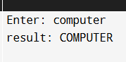
5.avg of array-no indexing
#include <stdio.h>

int main() {
int arr[] = {10, 20, 30, 40, 50};
int n = 5;
int sum = 0;
float avg;
int *ptr = arr;

for(int i = 0; i < n; i++) {
sum = sum + (*ptr+i);
ptr++;
}

avg = (float)sum / n;

printf("Average = %.2f", avg);

return 0;
}
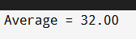
6.1st occurance of substring
#include <stdio.h>

int fun(const char str[], const char sub[]) {
int i = 0, j=0;

while (str[i] != '\0') {
while (sub[j] != '\0' && str[i + j] == sub[j]) {
j++;
}
if (sub[j] == '\0') {
return i;
}
i++;
}

return -1;
}

int main() {
char str[] = "hi alex";
char sub[] = "alex";

int index = fun(str, sub);

if (index != -1)
printf("Substring at %d\n", index);
else
printf("not found\n");

return 0;
}

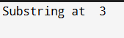
7.safe copy of content
#include <stdio.h>

void copy(const char *dest, const char *src, size_t n) {
if (n == 0) return;

size_t i;
for (i = 0; i < n - 1 && src[i] != '\0'; i++) {
dest[i] = src[i];
}
dest[i] = '\0';
}

int main() {
char src[100] = "embedded programming";
char dest[10];
copy(dest, src, sizeof(dest));

printf("Source: %s\n", src);
printf("Destination: %s\n", dest);

return 0;
}
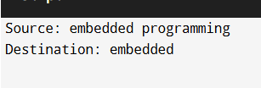
8.merge sort
#include <stdio.h>

int main() {
int arr1[] = {1, 3, 5, 7};
int arr2[] = {2, 4, 6, 8, 10};
int n1 = sizeof(arr1)/sizeof(arr1[0]);
int n2 = sizeof(arr2)/sizeof(arr2[0]);
int merged[n1 + n2];

int i = 0, j = 0, k = 0;

while (i < n1 && j < n2) {
if (arr1[i] <= arr2[j])
merged[k++] = arr1[i++];
else
merged[k++] = arr2[j++];
}

while (i < n1)
merged[k++] = arr1[i++];
while (j < n2)
merged[k++] = arr2[j++];

printf("Merged array: ");
for (i = 0; i < n1 + n2; i++)
printf("%d ", merged[i]);
printf("\n");

return 0;
}
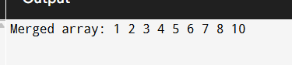
9.Arithmetic operations
#include <stdio.h>

int add(int a, int b) { return a + b; }
int subtract(int a, int b) { return a - b; }
int multiply(int a, int b) { return a * b; }
int divide(int a, int b) {
if (b != 0) return a / b;
else {
printf("Error\n");
return 0;
}
}

int main() {
int x, y, choice, result;
int (*operation)(int, int);

printf("Enter: ");
scanf("%d %d", &x, &y);

printf("Select:\n");
printf("1. Add\n2. Subtract\n3. Multiply\n4. Divide\n");
scanf("%d", &choice);

switch(choice) {
case 1: operation = add; break;
case 2: operation = subtract; break;
case 3: operation = multiply; break;
case 4: operation = divide; break;
default:
printf("Invalid\n");
return 0;
}

result = operation(x, y);
printf("Result = %d\n", result);

return 0;
}
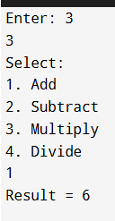
10.calculator using array pointer
#include <stdio.h>

int add(int a, int b) { return a + b; }
int subtract(int a, int b) { return a - b; }
int multiply(int a, int b) { return a * b; }
int divide(int a, int b) {
if (b != 0) return a / b;
else {
printf("Error\n");
return 0;
}
}

int main() {
int x, y, choice, result;

int (*calc[])(int, int) = {add, subtract, multiply, divide};

printf("Enter ");
scanf("%d %d", &x, &y);

printf("Select :\n");
printf("1. Add\n2. Subtract\n3. Multiply\n4. Divide\n");
scanf("%d", &choice);

if(choice < 1 || choice > 4) {
printf("Invalid\n");
return 0;
}

result = calc[choice - 1](x, y);
printf("Result = %d\n", result);

return 0;
}
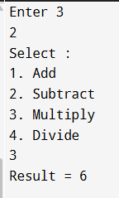
11.vector implementation
#include <stdio.h>
#include <stdlib.h>

typedef struct {
int *data;
int size;
int capacity;
} Vector;

void init(Vector *v, int cap) {
v->data = malloc(cap * sizeof(int));
v->size = 0;
v->capacity = cap;
}

void push(Vector *v, int val) {
if(v->size == v->capacity) {
v->capacity *= 2;
v->data = realloc(v->data, v->capacity * sizeof(int));
}
v->data[v->size++] = val;
}

int pop(Vector *v) {
if(v->size == 0) return -1;
return v->data[--v->size];
}
void resize(Vector *v, int new_capacity) {
v->capacity = new_capacity;
v->data = realloc(v->data, v->capacity * sizeof(int));
}
void printVector(Vector *v) {
for(int i = 0; i < v->size; i++)
printf("%d ", v->data[i]);
printf("\n");
}

int main() {
Vector v;
init(&v, 2);

push(&v, 10);
push(&v, 20);
push(&v, 30);
resize(&v,10);

printf("Vector: ");
printVector(&v);

printf("Popped: %d\n", pop(&v));

printf("Vector now: ");
printVector(&v);

free(v.data);
return 0;
}
